Midterm2 Review
• 5 problems
• Topics: • Constraint satisfaction problem • Min-max search • Propositional logic
Constraint Satisfaction Problems(CSP)
• A powerful representation for (discrete) search problems.
• A Constraint Satisfaction Problem (CSP) is defined by:
• X is a set of n variables X1 , X2 , ...., Xn , each defined by afinitedomainD1 , D2 , ..., Dn of possible values
• C is a set of constraints C1 , C2 , ..., Cm. Each Ci involves some subset of the variables; specifies the allowable combinations of values for that subset.
A solution is an assignment of values to the variables that satisfies all constraints.

Map-Coloring Problem
• Variables: WA, NT, Q, NSW, V, SA, T
• Domains: {red, green, blue}
• Constraints: Adjacent regions must have different colors
Implicit: WA ≠ NT
Explicit: (WA, NT) ∈ {(red, green), {red, blue}, ...}.
How to View a CSP as a Search Problem?
• Initial State -- the state in which all the variables are unassigned.
• Successor function -- assign a value to a variable from set of possible values.
• Goal test -- check if all the variables are assigned and all the constraints are satisfied. We call the assignment is complete.
• Path cost -- assumes constant cost for each step
The Backtracking Search Algorithm
Backtrack(assignment, csp):
If assignment is complete then return assignment
var ← select one unassigned variable
for each value in the domain of var do
if value is consistent with assignment then
add {var = value} to assignment
result ← Backtrack(assignment, csp)
if result ≠ failure then
return result
remove {var = value} from assignment
return failure
Backtracking Example

The Backtracking Search Algorithm
Backtrack(assignment, csp):
If assignment is complete then return assignment
var ← select one unassigned variable ← which one to select?
for each value in the domain of var do ← which one to use?
if value is consistent with assignment then
add {var = value} to assignment ← detect failure early
result ← Backtrack(assignment, csp)
if result ≠ failure then
return result
remove {var = value} from assignment
return failure
Improving Backtracking Efficiency
General-purpose methods can give huge gains in speed:
1. Which variable should be assigned next?
  - Choose the most constrained variable, and break ties by choosing the most constraining variable
2. In what order should its values be tried?
  - Choose the least constraining value
3. Can we detect inevitable failure early?
  - Forward checking, constraint propagation
Improving Backtracking Efficiency
1. Which variable should be assigned next?
  - Choose the most constrained variable, and break ties by choosing the most constraining variable

Variable Selection Heuristic 1: Most Constrained Variable

Most constrained variable:
Choose the variable with the fewest legal values a.k.a. mininum remaining values (MRV) heuristic
- Why min rather than max?
- “Fail-fast” ordering
- 1000× faster or more

Variable Selection Heuristic 2: Most Constraining Variable
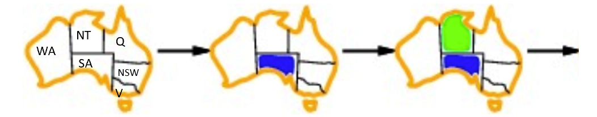
- Tie-breaker among most constrained variables
Most constraining variable:
- choose the variable with the most constraints on remaining variables

Improving Backtracking Efficiency
2. In what order should its values be tried?
Choose the least constraining value
Value Select Heuristic: Least Constraining Value
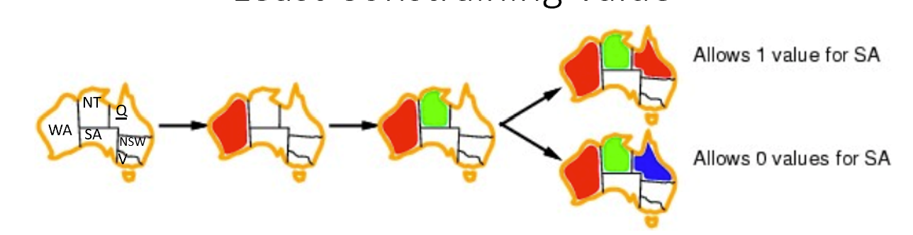
- Given a variable, choose the least constraining value:
the one that rules out the fewest values in the remaining variables
- Why least rather than most?
Variable and Value Ordering Heuristics
- The heuristics should be applied whenever a variable/value needs be chosen during the search process
- They should not be applied once and for all at the beginning of the search process
Improving Backtracking Efficiency
3. Can we detect inevitable failure early?
  - Forward checking, constraint propagation
Consistency-Enforcing Procedure 1: Forward Checking
- Idea:
Keep track of remaining legal values for unsigned variables
Terminate search when any variable has no legal values.
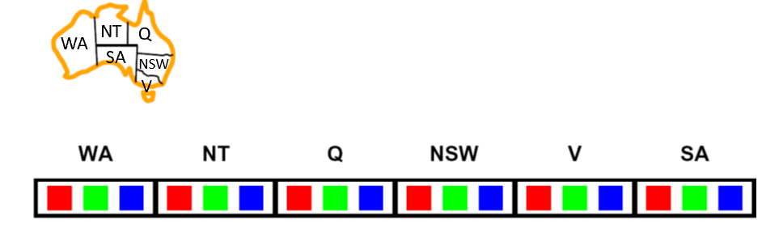
Consistency-Enforcing Procedure 2: Constraint Propagation
- Forward checking propagates information from assigned to unassigned variables, but doesn't provide early detection for all failures:
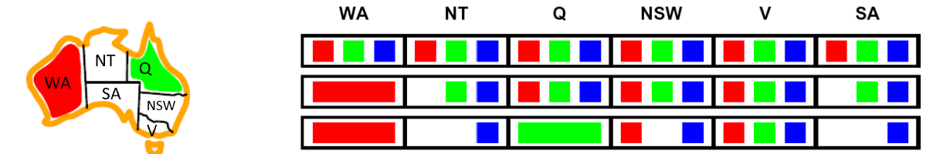
- NT and SA cannot both be blue!
- Constraint propagation repeatedly enforces constrains locally.
Consistency-Enforcing Procedure 2: Constraint Propagation
- Using the constraints to reduce the number of legal values for a variable
- Constraint propagation may be intertwined with search, or it may be done as a preprocessing step, before search starts
- Sometimes this preprocessing can solve the whole problem, so no search is required at all!
- Local consistency

Arc Consistency
- An arc X → Y is consistent iff for every x in the tail there is some y in the head which could be assigned without violating a constraint
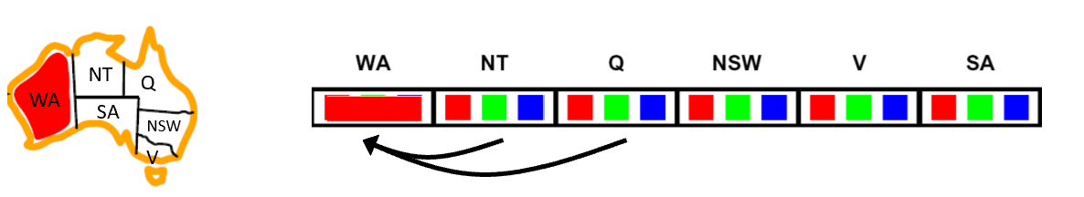
- Forward checking: Enforcing consistency of arcs pointing to each new assignment
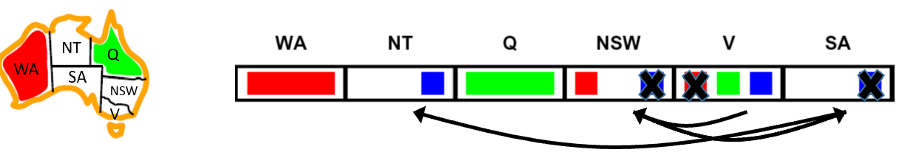
. Arc consistency detects failure earlier than forward checking
. Can be run as a preprocessor or after each assignment
Consistency-Enforcing Procedures
• Forward checking • Constraint propagation • Variable/value ordering heuristics
• They can used in combination to improve search process.
General Purpose CSP Algorithm
1. If all values have been successfully assigned then stop, else go on to 2.
2. Apply the consistency enforcing procedure (e.g. forward checking if feeling computationally mean, or constraint propagation if extravagant.)
3. If a deadend is detected then backtrack (e.g., DFS-type backtrack.). Else go on to step 4.
4. Select the next variable to be assigned (using your variable ordering heuristic)
5. Select a promising value (using your value ordering heuristic) 6. Create a new search state. Cache the info you need for backtracking. And go back to 1.


Deterministic Games
• One possible formulation
• States: S (start at s₀ )
• Players: P = {1...N} (usually take turns)
• Actions: A (may depend on player / state)
• Transition Function: S x A → S • Terminal Test: S → {True, False}
• Terminal Utilities: SxP → R
• Solution for a player is a policy: S →A
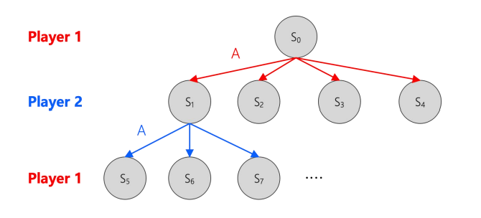
Game Playing as Search
• We can list all the possible actions and states
• In each step, play 1 searches for an action which leads to the maximum utility.
Search Tree for Tic-Tac-Toe
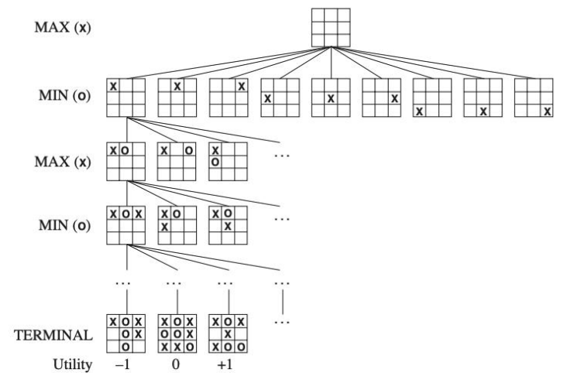
Tic-Tac-Toe
• High values are good for MAX and bad for MIN. It is MAX’s job to use the search tree and utility values to determine the best move.
• Root is initial position. Next level are all moves player 1(MAX) can make; tree is from Max’s viewpoint. Next level are all possible responses from player 2 (MIN).
• Max has to find a strategy that will lead to a winning terminal state regardless of what Min does. Strategy has to include the correct move for Max for each possible move by Min.
Minimax Values
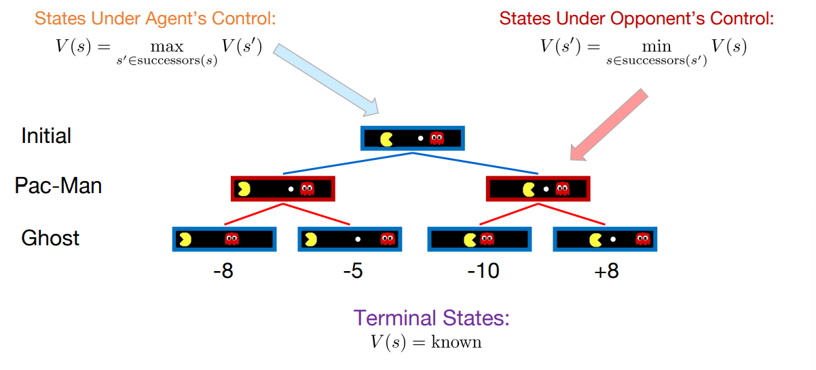
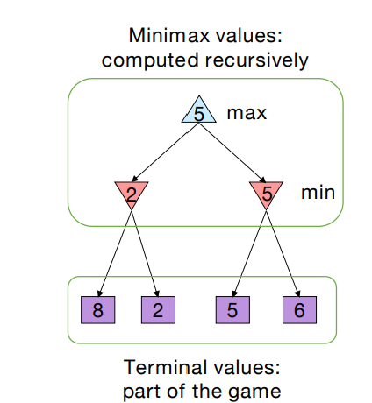
Minimax Search
• Deterministic, zero-sum games:
• Tic-tac-toe, chess, checkers
• One player maximizes result
• The other minimizes result
• Compute each node’s minimax value:
• the best achievable utility against a rational (optimal) adversary
Simplified Minimax Algorithm
1. Expand the entire tree below the root
2. Evaluate the terminal nodes as wins for the minimizer or maximizer
3. Select an unlabeled node, n, all of whose children have been assigned values. If there is no such node, we’re done —return the value assigned to the root.
4. If n is a minimizer move, assign it a value that is the minimum of the values of its children. If n is a maximizer move, assign it a value that is the maximum of the values of its children. Return to Step 3.
Another Example
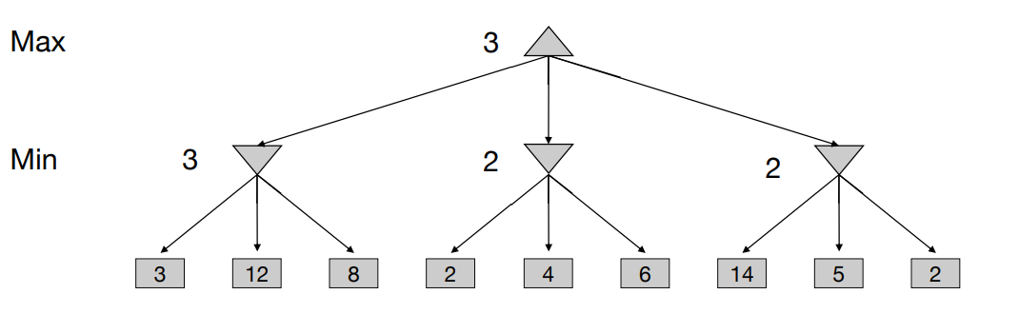
α - β pruning
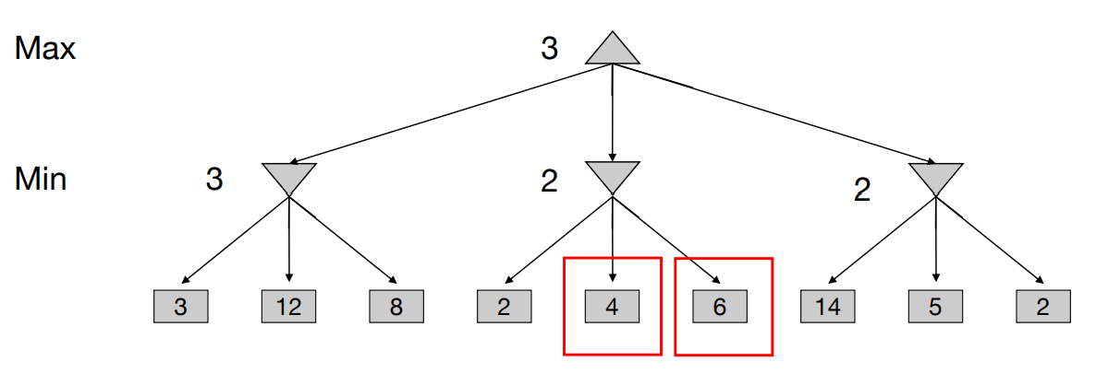

Improving Minimax -- α- βpruning
• The number of game states is exponential in the depth of the tree.
• It is possible to prune large parts of the tree from consideration.
• Intuition: prune away branches that cannot possibly in fluence the value of the state.
α - β Pruning
Beta: an upper bound on the value that a min node may ultimately be assigned at that level or above Alpha: a lower bound on the value that a max node may ultimately be assigned at that level or above.
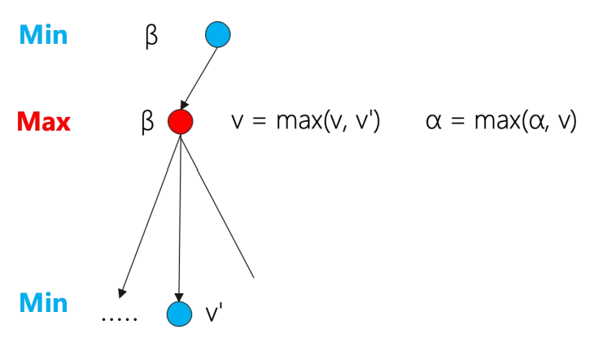
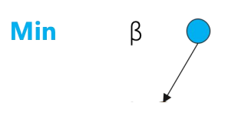
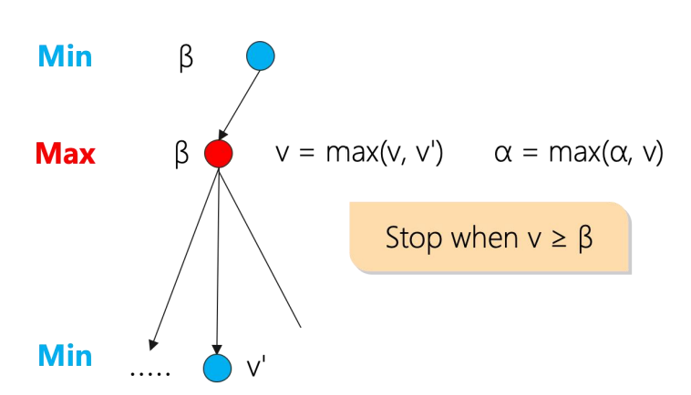
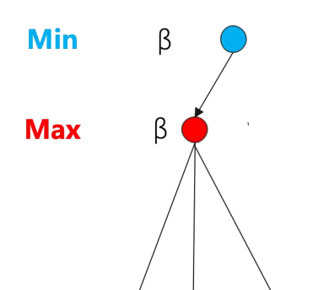
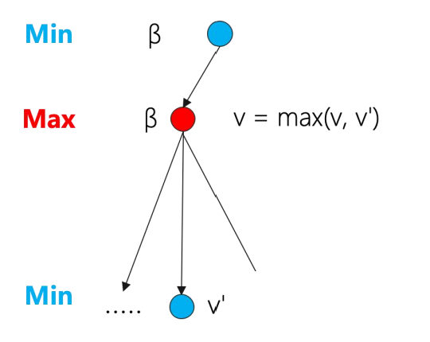

α - β Search Quiz
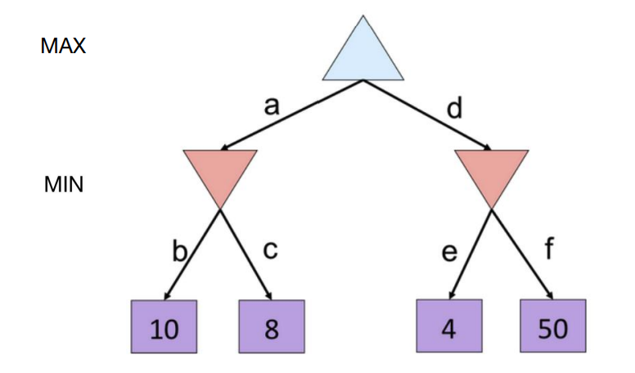
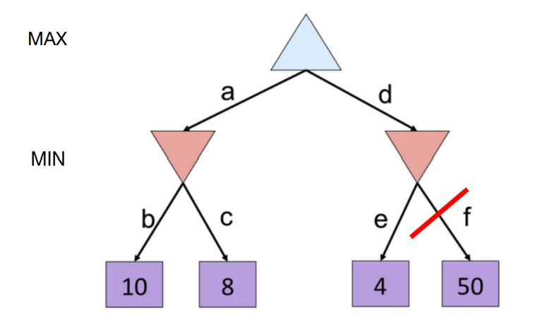
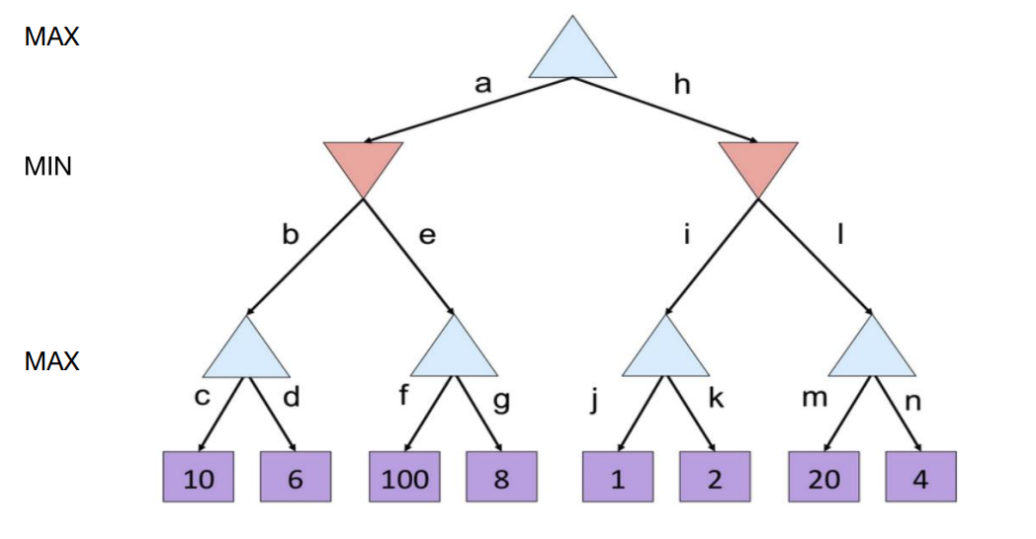
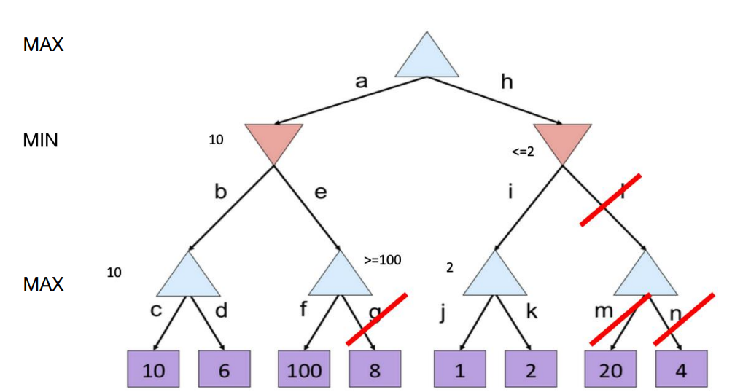

Logic
• Logic: • defines a formal language for logical reasoning
• It gives us a tool that helps us to understand how to construct a valid argument
• Logic defines: • the meaning of statements • the rules of logical inference
Logic as a Knowledge Representation
Three components:
• syntax: specifies which sentences can be constructed in a given formal logic
• E.g. x + y = 4
• semantics: specifies what a sentence means
• x + y = 4 is True if x = 2 and y = 2
• proof theory: a set of general purpose rules that allow efficient derivation of new information from the sentences in the knowledge base.
Logic as a Knowledge Representation
Model: a truth assignment to every propositional symbol
Logic entailment: A sentence follows logically from another sentence: 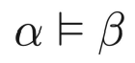
In every model in which α is true, β is also true.
Logic as a Knowledge Representation
• Logic inference:
• Given a knowledge base KB and a sentence α
• Does a KB semantically entail α? KB ⊨ α
One possible approach: Model Checking: enumerate all the possible models to check if α is true in all models in which KB is true.
KR Language: Propositional Logic
• Literal: an atomic formula or its negation - Positive literal: P, Q - Negative literal: ¬P, ¬Q
• Syntax: build sentences from atomic propositions, using connectives:
• ∧: and • ∨: or • ¬ : not • ⇒ : implies • ⇔ : equivalence (biconditional)
KR Language: Propositional Logic
Syntax: build sentences from atomic propositions, using connectives
∧, ∨, ¬ , ⇒, ⇔ (and / or / not / implies / equivalence (biconditional))
E.g.: ¬P
Q ∧ R
( ¬P ∨ (Q ∧ R)) ⇒ S
KR Language: Propositional Logic
• Clause: a disjunction of literals E.g.: Q ∨ R
• Conjunctive normal form (CNF): a conjunction of clauses E.g.: (Q ∨ R) ∧(P ∨R)
• Every formula can be equivalently written as a formula in conjunctive normal form
(Q ∧ R) ∨ P → (Q ∨P)∧(R ∨P )
Semantics
Semantics specifies what something means.
In propositional logic, the semantics (i.e., meaning) of a sentence is the set of interpretations (i.e., truth assignments) in which the sentence evaluates to True.
Example:
The semantics of the sentence P∨Q ⇒ R is
• P is True, Q is True, R is True
• P is True , Q is False, R is True
• P is False , Q is True , R is True
• P is False , Q is False , R is True
• P is False , Q is False , R is False
Evaluating a sentence under interpretation I
We can evaluate a sentence using a truth table
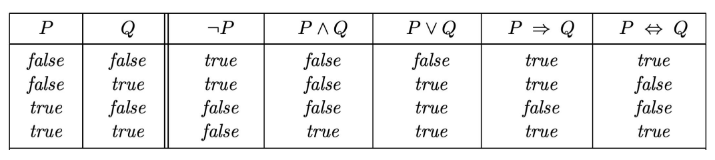
Note: is somewhat counterintuitive
What's the true value of “5 is even implies Sam is smart” If P is True, then I claim Q is True
Three Important Concepts
• Logic Equivalence • Validity • Satisfiability
Logic Equivalence
• Two sentences are equivalent if they are true in the same set of models.
• We write this as α ≡ β. α ≡ β if and only if α ⊨ βandβ⊨α
For example: I. If Lisa is in Denmark, then she is in Europe
II. If Lisa is not in Europe, then she is not in Denmark
Logic Equivalence
• (α∧β) ≡ (β∧α) commutativity of ∧
• (α∨β) ≡ (β∨α) commutativity of ∨
• ((α∧β) ∧γ) ≡ (α∧(β ∧γ)) associativity of ∧
• ((α∨β) ∨γ) ≡ (α∨(β ∨γ)) associativity of ∨
• ¬(¬ α) = α double-negation
• (α ⇒ β) ≡ (¬β ⇒ ¬α) contraposition
• (α ⇒ β) ≡ (¬α∨β) implication elimination
• (α ⇔ β) ≡ ((α ⇒ β) ∧(β ⇒ α)) biconditional elimination
• ¬(α∧β) ≡ (¬α∨¬β) De Morgan
• ¬(α∨β) ≡ (¬α∧¬β) De Morgan
• (α∧(β∨γ)) ≡ ((α∧β)∨(α∧γ)) distributivity of ∧ over ∨
• (α∨(β∧γ)) ≡ ((α∨β)∧(α∨γ)) distributivity of ∨ over ∧
These equivalences play much the same role in logic as arithmetic identities do in ordinary mathematics.
Validity
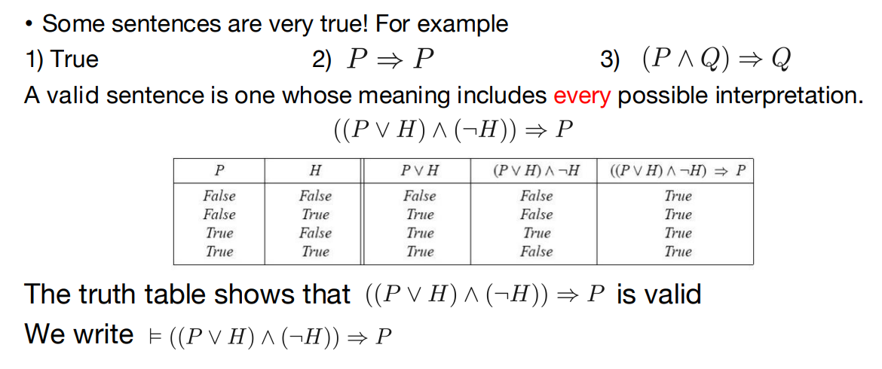
Satisfiability
• An unsatisfiable sentence is one whose meaning has no interpretation(e.g., P∧¬P )
• A satisfiable sentence is one whose meaning has at least one interpretation.
• A sentence must be either satisfiable or unsatisfiable but it can’t be both.
• If a sentence is valid then it’s satisfiable.
• If a sentence is satisfiable then it may or may not be valid.
• The SAT problem is to determine the satisfiability of sentences
• Connection to validity:
• α is valid iff ¬α is unsatisfiable
• α is satisfiable iff ¬α is not valid
• Proving by checking the unsatisfiability: α ⊨ β if and only if the sentence (α ∧¬β) is unsatisfiable
Note:
A formula is valid if it is true for all values of its terms. Satisfiability refers to the existence of a combination of values to make the expression true. So in short, a proposition is satisfiable if there is at least one true result in its truth table, and valid if all values it returns in the truth table are true.
Convert to CNF
• Convert ( B_{1,1} ⇔ (P_{1,2} ∨ P_{2,1} ) ) ∧¬B_{1,1}∧P_{1,2} into CNF
• ((B_{1,1}⇒(P_{1,2} ∨ P_{2,1} )) ∧ ((P_{1,2} ∨ P_{2,1} ) ⇒B_{1,1} )) ∧¬B_{1,1}∧P_{1,2} (biconditional)
• ((¬B_{1,1} ∨(P_{1,2} ∨ P_{2,1} )) ∧(¬(P_{1,2} ∨ P_{2,1} ) ∨B_{1,1} ) ∧¬B_{1,1}∧P_{1,2} (Implication elimination)
• (¬B_{1,1} ∨P_{1,2} ∨ P_{2,1} ) ∧((¬P_{1,2} ∧ ¬P_{2,1} )∨ B_{1,1} ) ∧¬B_{1,1}∧P_{1,2} (De Morgan)
• (¬B_{1,1} ∨P_{1,2} ∨ P_{2,1} ) ∧(¬P_{1,2}∨ B_{1,1} ) ∧(¬P_{2,1}∨B_{1,1} )∧¬B_{1,1}∧P_{1,2} (Distri.)

